**Dessert Hub**

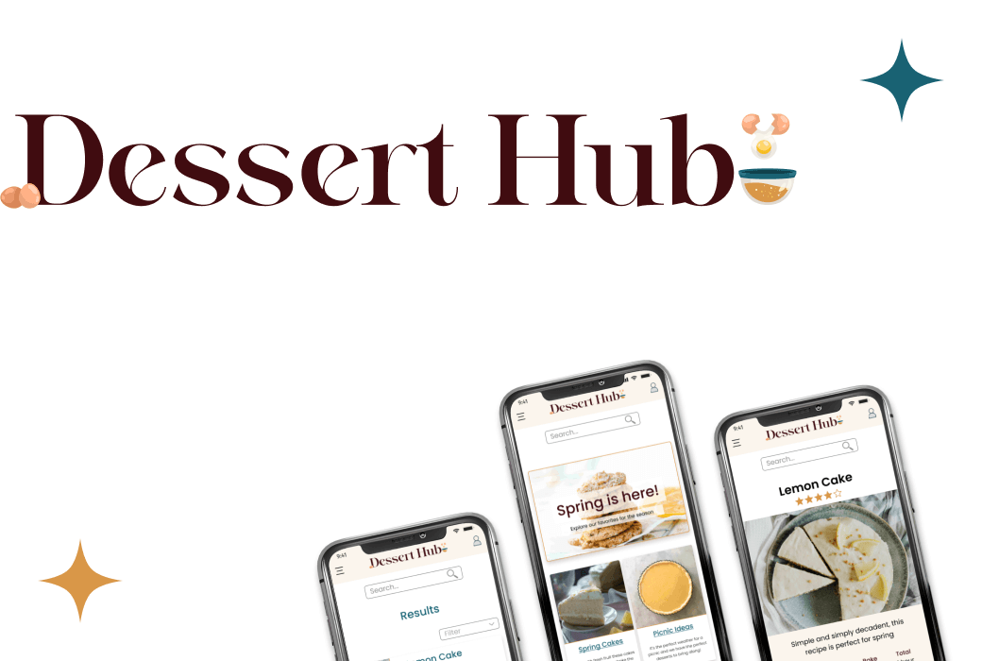

Dessert Hub focuses on creating a solution for users who dislike or struggle with the current selection of recipe sites that are available. This site focuses on creating user-centered design and solving problems that potential users brought up during interviews and design testing. My design reflects my user’s needs and helps them achieve their goals.

**Research**

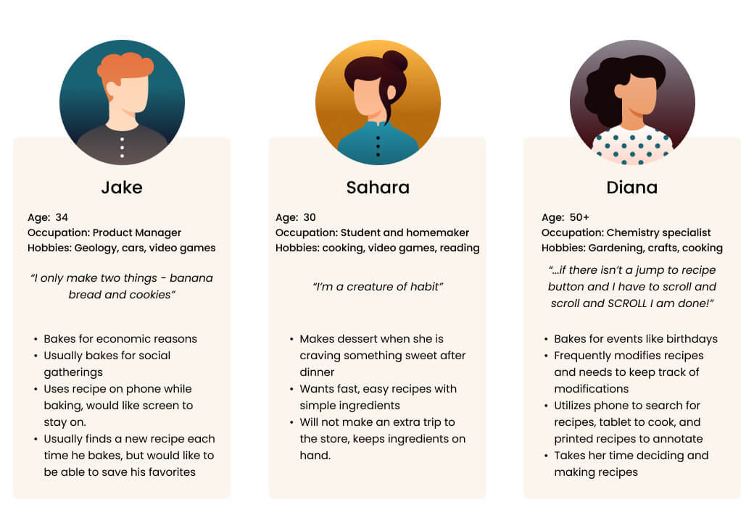

I did several rounds of interviews and user testing during the research phase and beyond to create this project. I wanted the design to be based on what my users were wanting, and what worked best to fulfill their needs

**Ideation**

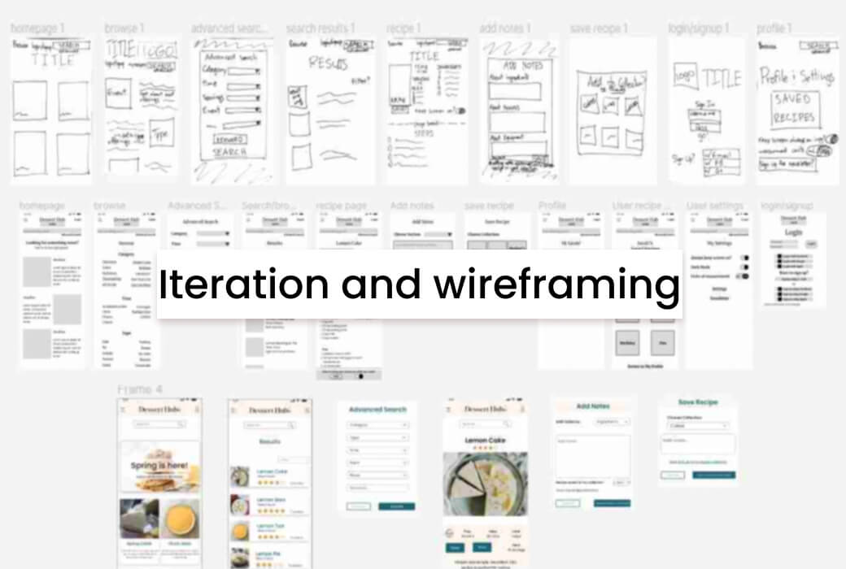

From low-fi sketches to high fidelity wireframes my users and their needs were kept at the forefront of the design.

**Design**

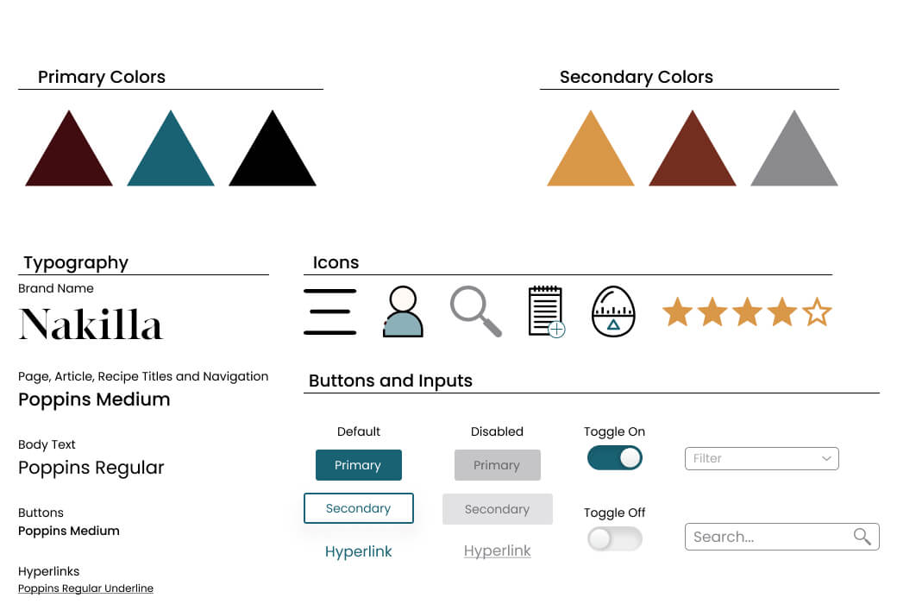

Bold, fun colors and easy to read text make using Dessert Hub accessible and fun. Unique bespoke icons make finding information on pages easy and simple, while maintaining an easily identifiable brand.

**Prototype**

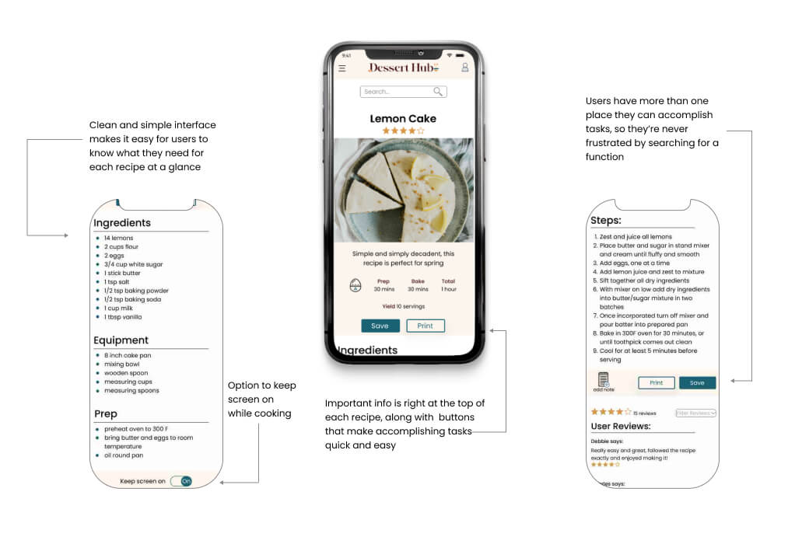

The final design is a combination of a clear and distinct brand with ease and accessibility. User requested features blend seamlessly into a simple design that remains fun and exciting.

**Conclusion**

Dessert Hub embodies a user-centric approach, driven by insights gathered from interviews and design testing. The MVP features were meticulously crafted to address specific user needs, such as annotating and printing recipes. Valuable feedback throughout the design process prompted adjustments and changes. Looking ahead, streamlining style settings and libraries will be a priority in future projects, optimizing efficiency from the outset. This project showcases a commitment to creating a solution that truly meets the unique preferences and challenges faced by users in the realm of recipe platforms.